Logical Model: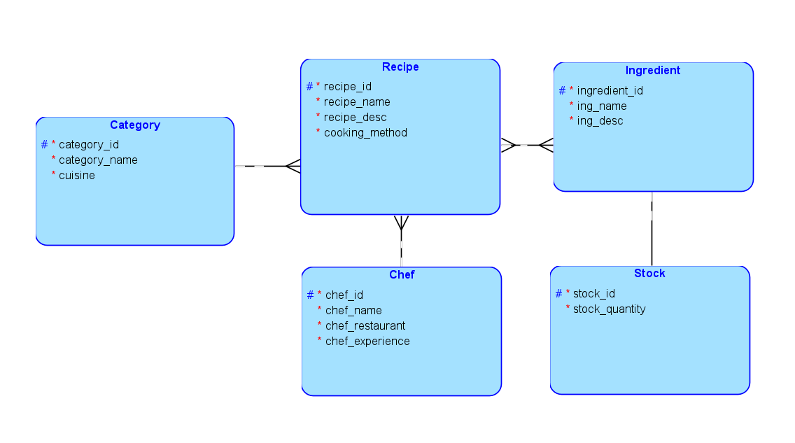

Relational Model:

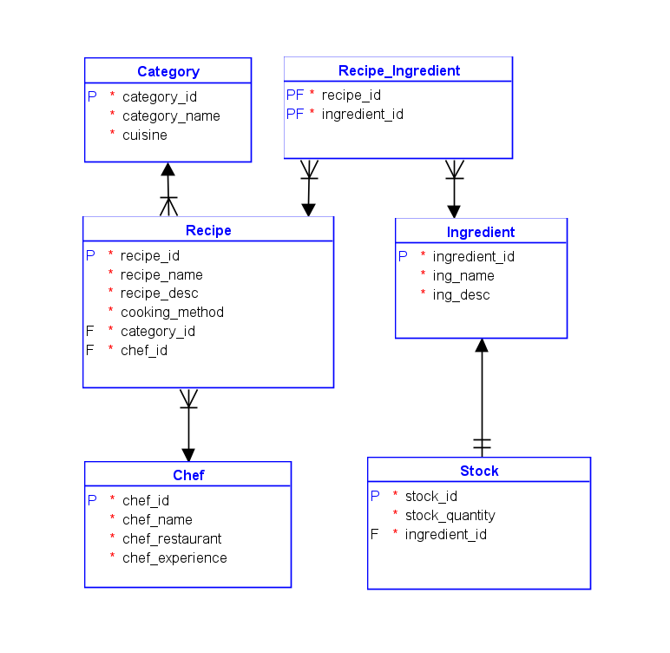

Table 1: Recipe

* int recipe_id
* Varchar recipe_name
* Varchar desc
* int category_id
* Int ingredient_id
* Int chef_id
* Varchar cooking_method

Table 2: Recipe Category

* Int category_id
* Varchar category_name
* Varchar cuisine

Table 3: Ingredient

* Int ingredient_id
* Varchar ing_name
* Varchar ing_desc
* Int stock_id

Table 4: Stock

* Int Stock_id
* Int stock_quantity

Table 5: Chef

* Int chef_id
* Varchar chef_name
* Varchar chef_restaurant
* Int chef_experience